**A3 – User Interface prototype**

This prototype seeks to preview and test the user interface of our web application, helping not only to identify but also find new user requirements. It also should allow us to preview and test the user interface of the website, as well as enable iterations on the design.

Taking this into consideration, we developed a three-part artifact with: overview of the interface and features common to all pages; sitemap (scheme that allows visualization of the information system from the viewpoint of the user, like the existing pages on the website and their connections); storyboards (sequence of pages that are accessed through others, by interacting with the system).

**1 – Interface and common features \***

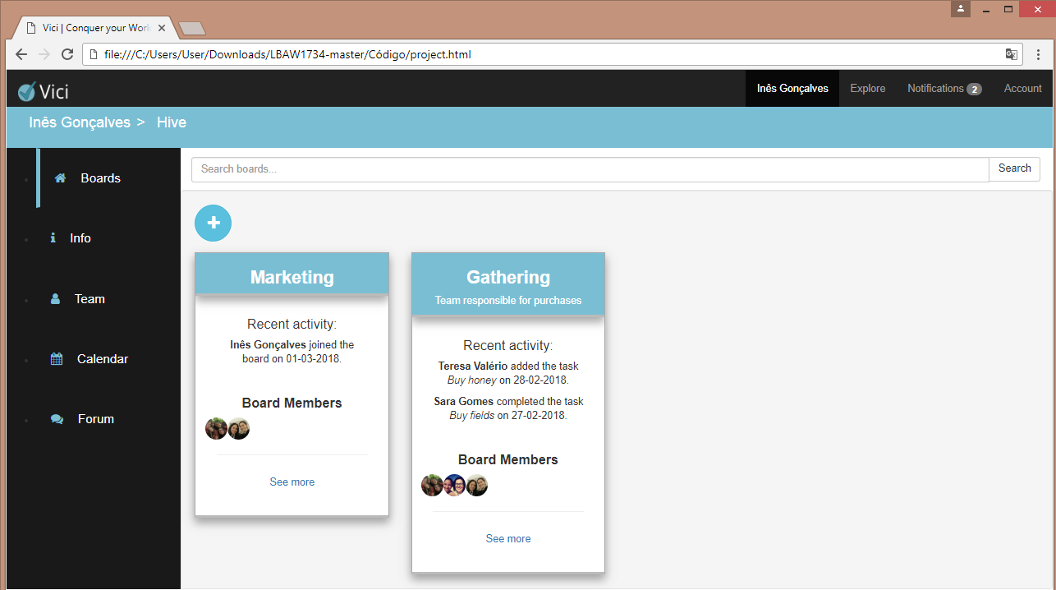

**4**

**22**

**12**

**322**

**5**

**6**

Figure 1. Basic Interface Elements

*Features common to all pages except homepage.

1. Page title

2. Logo

3. Breadcrumbs

4. Logo

5. Navbar

6. Content

We opted to have a fixed sidebar to ease transition between pages and a breadcrumb system, so the user can keep track of his position on the website and define a clear hierarchy of information. The navbar and its links stay the same throughout the website to make the user experience consistent. Colors were chosen to keep a soft look, easy to work with, even for long periods of time.

**2 – Sitemap**

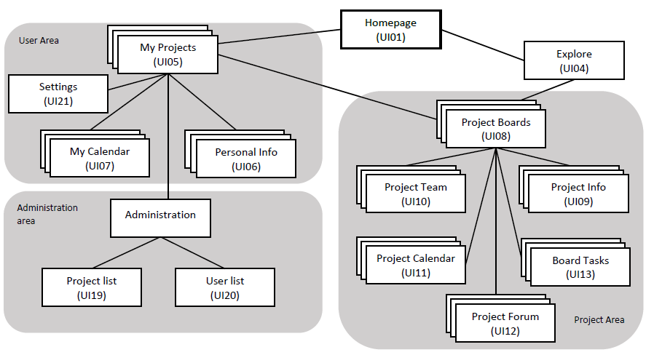The sitemap was built so the team could have a visual representation of the relationship between different pages. It is important to note that the administration page is only available to users that have administrator permissions.

Figure 2. Sitemap

**3 – Storyboards**

On the first page, the user can click on “Log in or Create an Account” which will make a pop-up appear, so that login can be made. If the user doesn’t have an account, he can click on “Register”, that will make a new pop up appear that allows the user to create an account. By clicking on “Log in” the user can go back to the previous pop up.

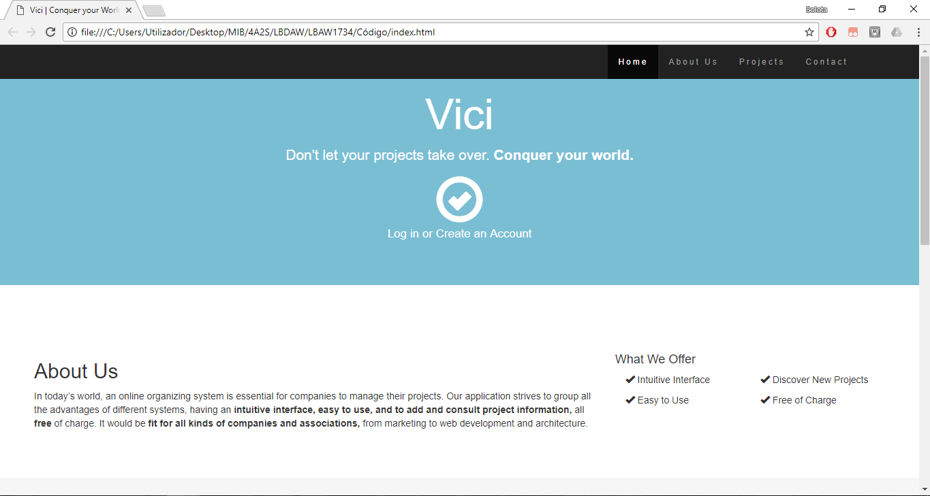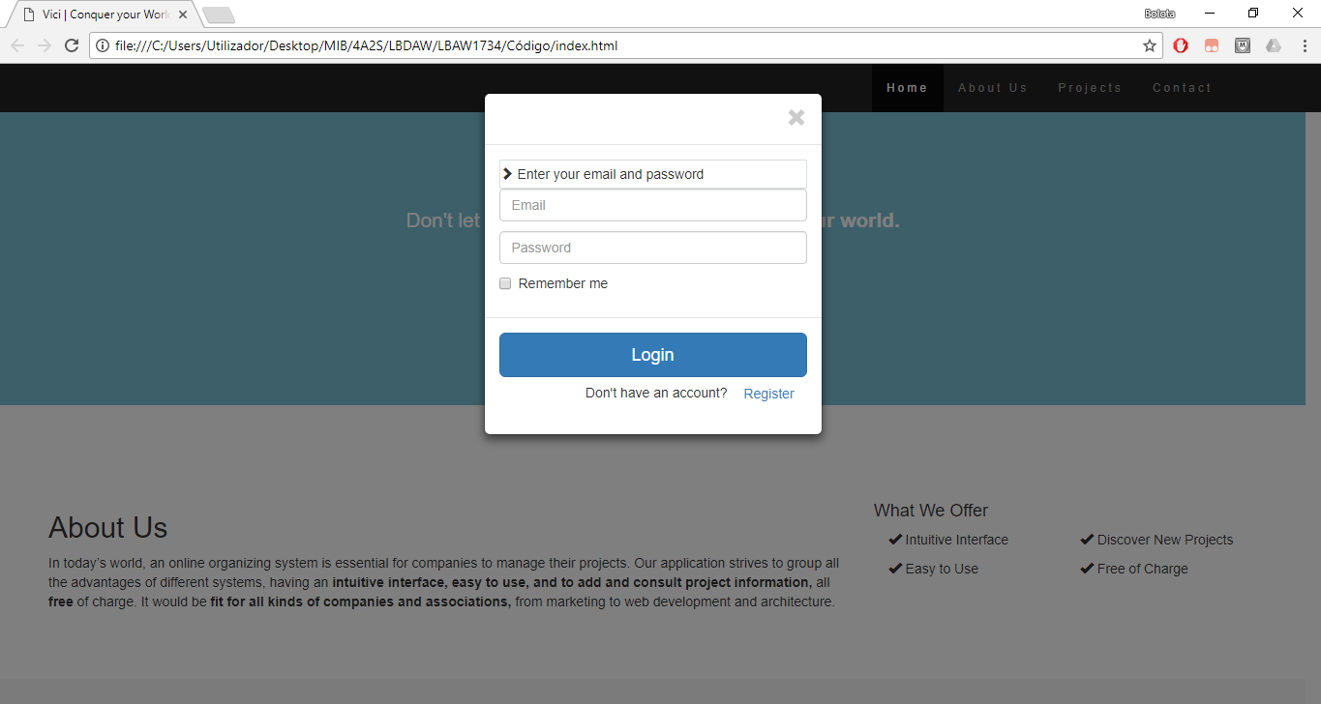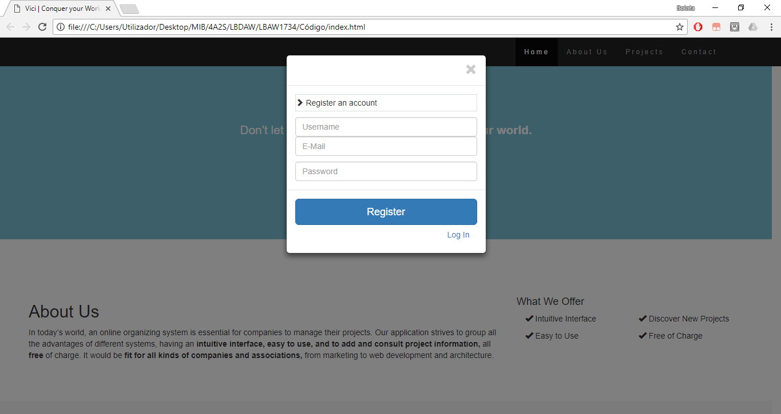

Figure 3. Wireflow centered on the homepage

After logging in the user can access the main portion of the website and no longer has access to the homepage until logout.

After logging in, the first page the user has access is the projects page (includes projects he created and projects he is working on). Here, the user can navigate in the left bar, switching between three pages: “My projects” (the one presented after logging in), “Personal Info” and “My Calendar”.

Figure 4. Wireflow centered in the user’s areas.

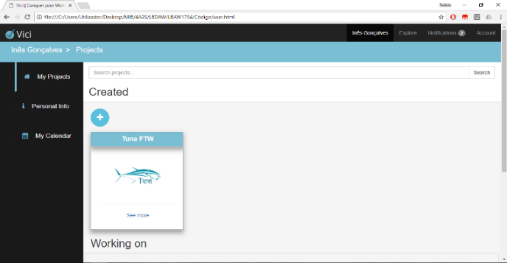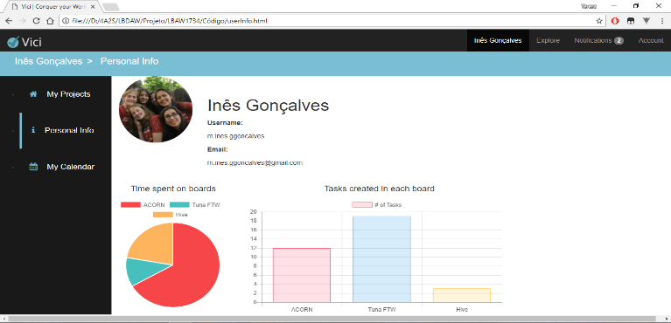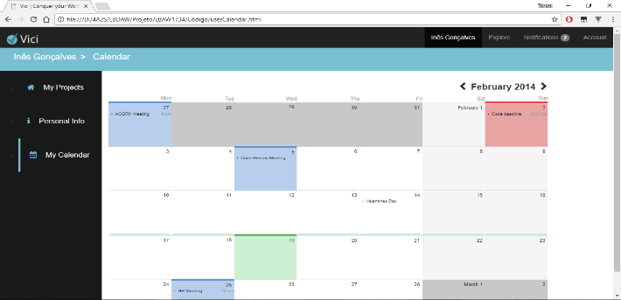

In the “My Projects” page, the user can choose to create a new project by clicking on the plus icon (a pop up will arise so that a new project can be created), or click on “See more” hyperlink to open a new page with more information about the task. The first page is the “Boards” page. There, the user can create a new board by clicking on the plus icon or open a new page containing more information about that board by clicking on “See more”. When opting by the last one, a page appears showing the tasks included in that board. Once again, by clicking on the plus icon a new task can be created. Also, you can see more about that task or update it, by clicking on “See more” and “Update”, respectively.

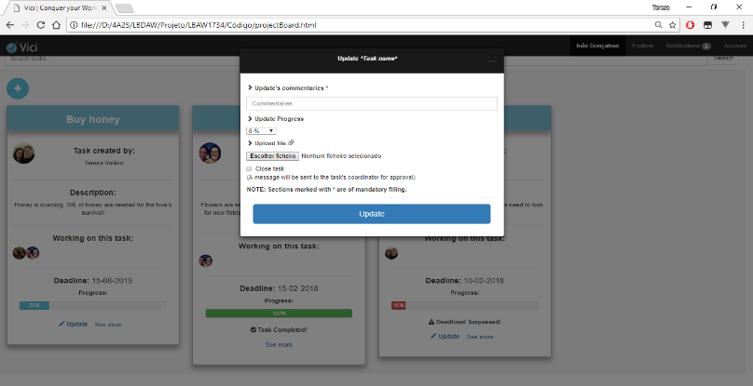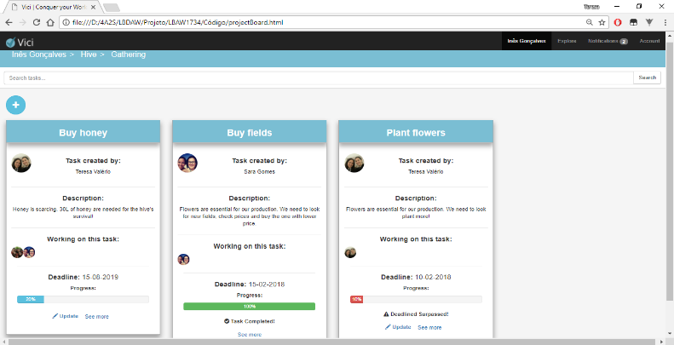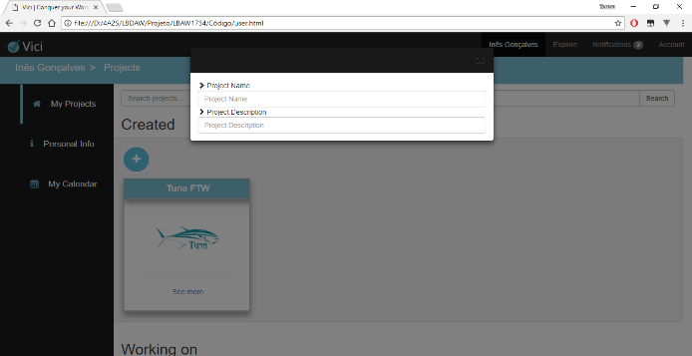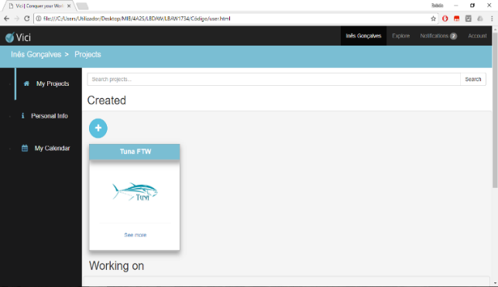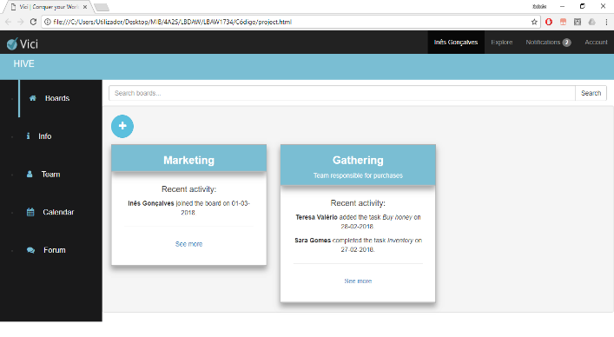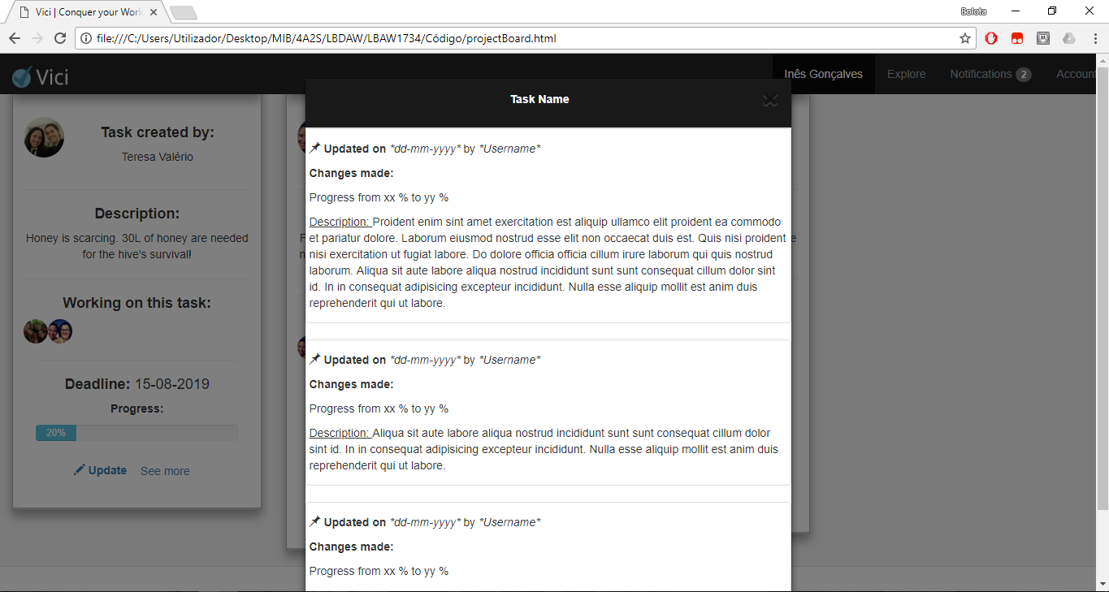

Figure 5. Wireflow centered in the project’s functionalities.

As well as in the user’s area, the project’s area also allows navigation between several pages by clicking on the different icons on the left side bar. These pages are: “Boards” (the initial one that shows the project’s boards), “Info” (shows some information about the project as well as some statistics), “Team” (allows the user to see the workers involved in the project and some information about them), “Calendar” (includes meetings and deadlines of that project) and “Forum” (place where the project workers can discuss importante issues).

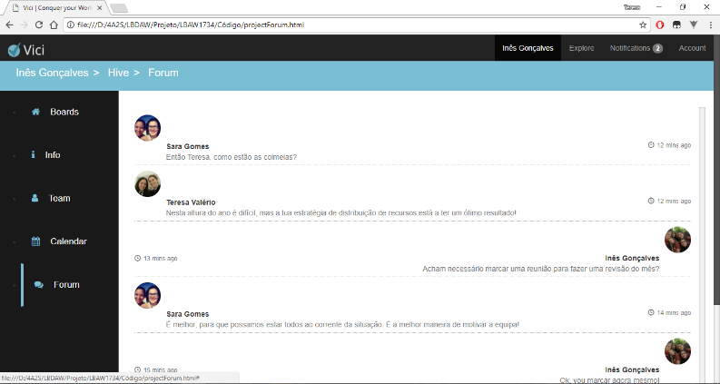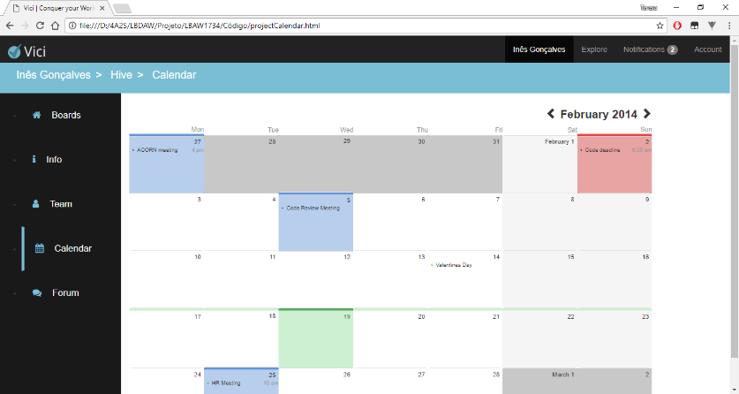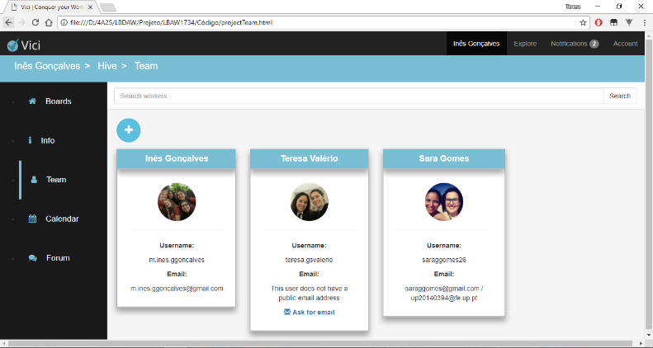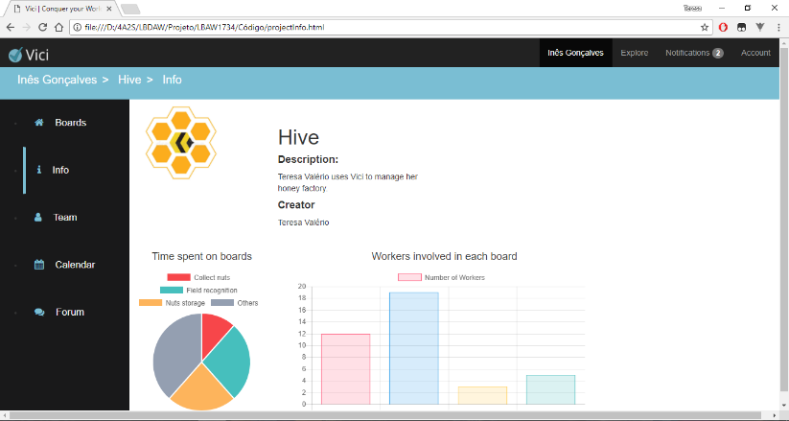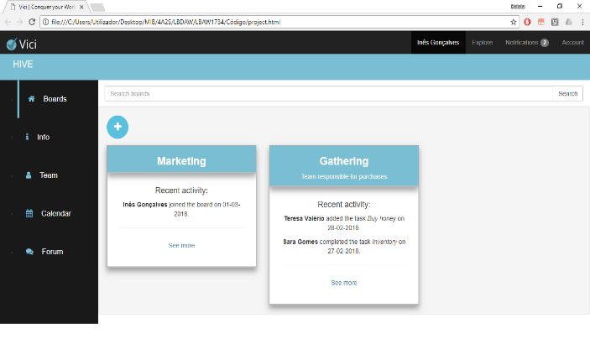

Figure 6. Wireflow centered in the project’s areas.

In every page the user can access other functionalities using the navbar. Also, by clicking on a hyperlink of the breadcrumbs on each page, the user can return to a previous page.

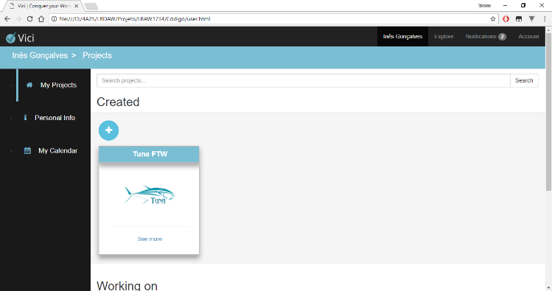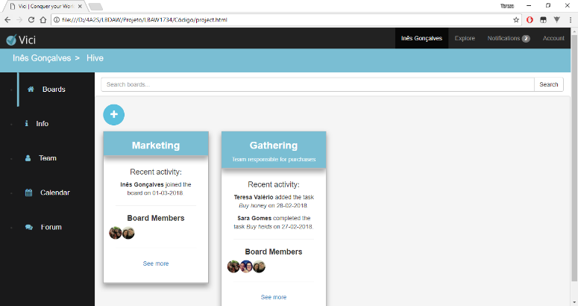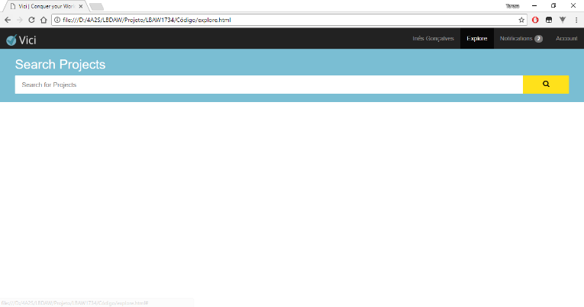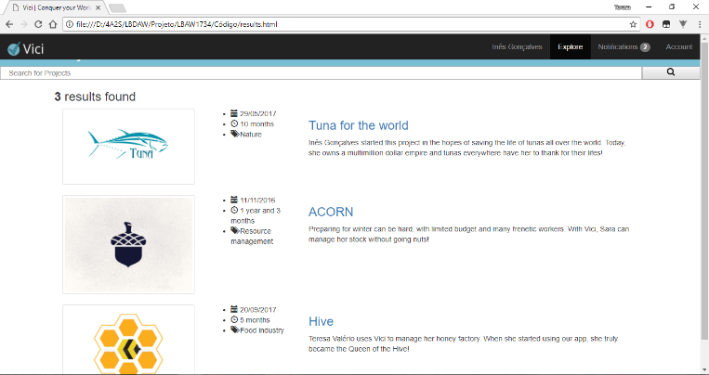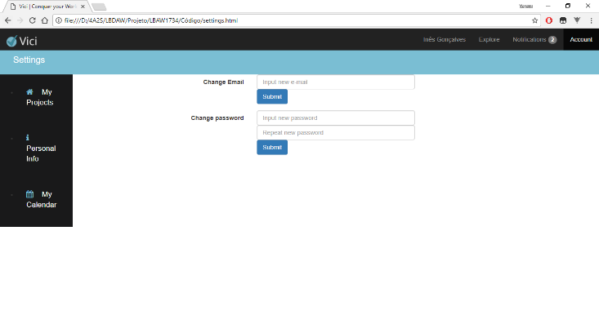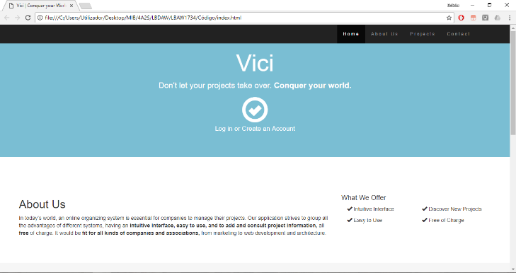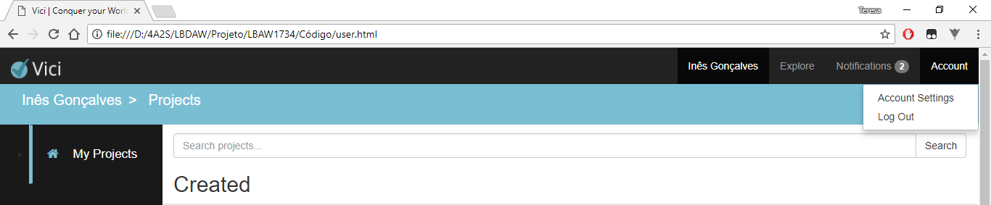

Figure 7. Wireflow centered in navbar.

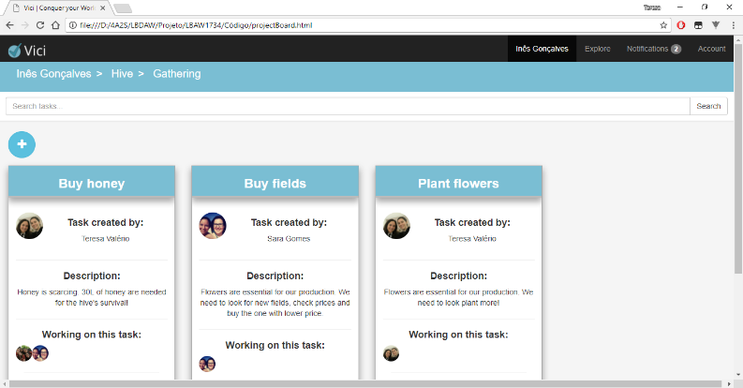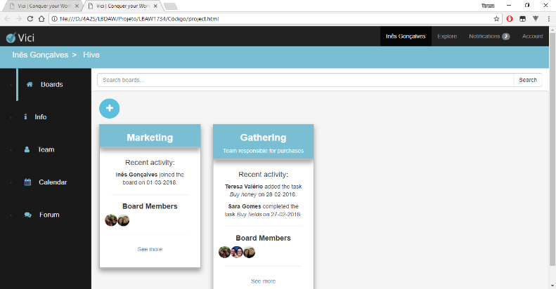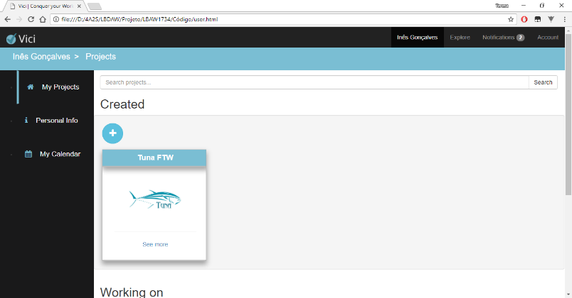

Figure 8. Wireflow centered in breadcrumbs.

**4 – Interfaces**

**UI01 – Home**

(https://teresavalerio.github.io/LBAW1734/C%C3%B3digo/)

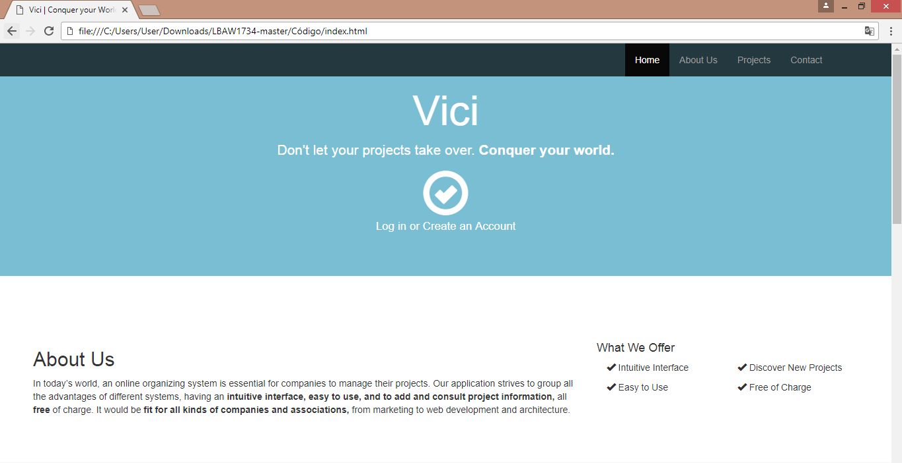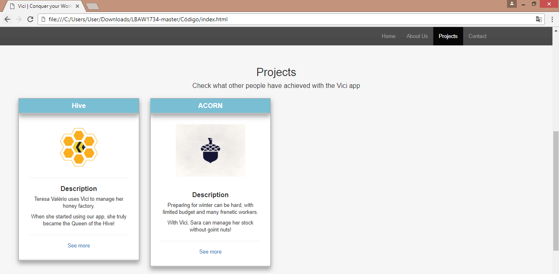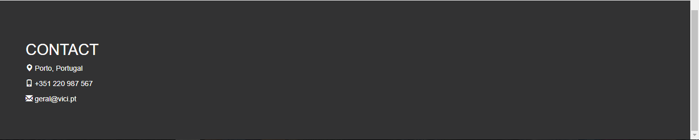

Figure 9. Homepage

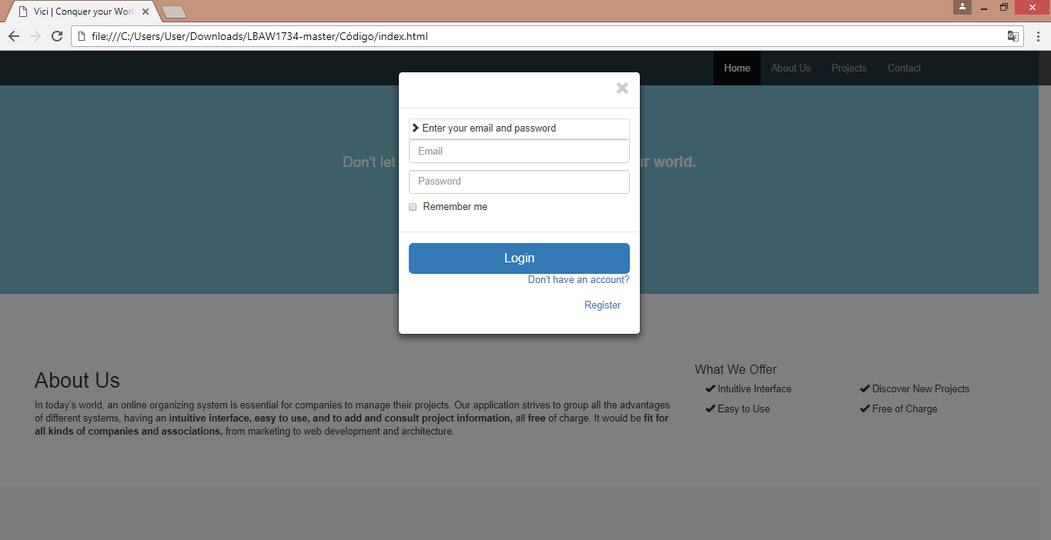**UI02 – Log in**

Figure 10. Log in pop up

**UI03 – Register**

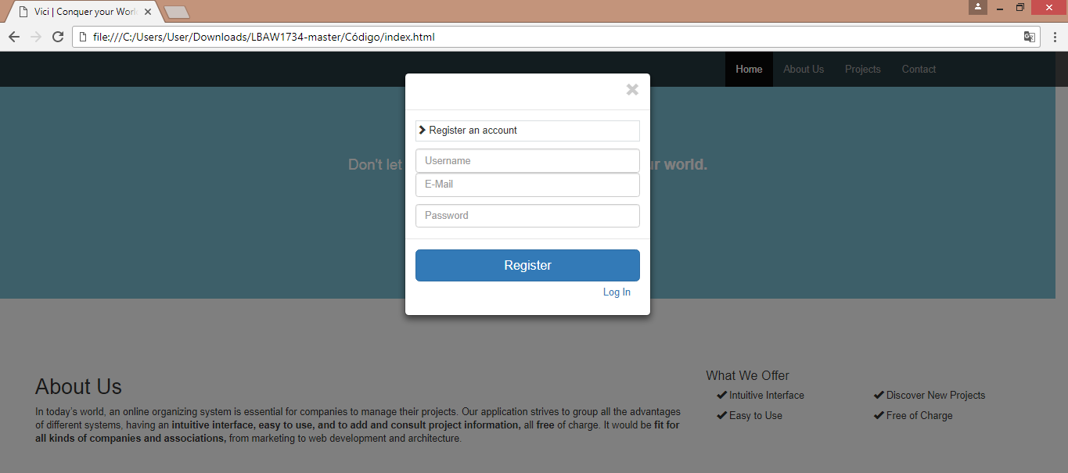

Figure 11. Register pop up

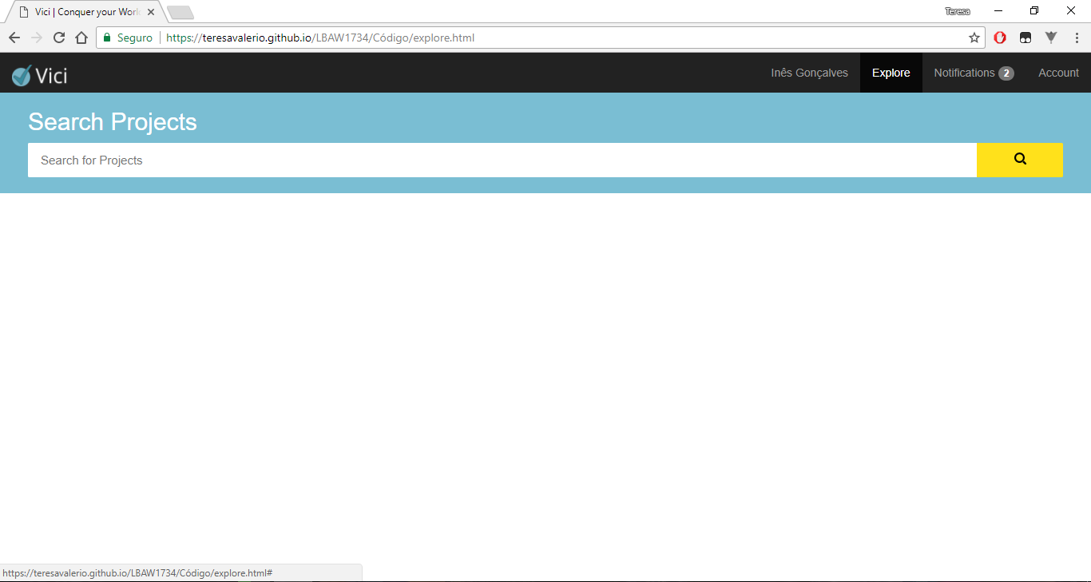**UI04 – Explore** (<https://teresavalerio.github.io/LBAW1734/C%C3%B3digo/explore.html>)

Figure 12. Explore page

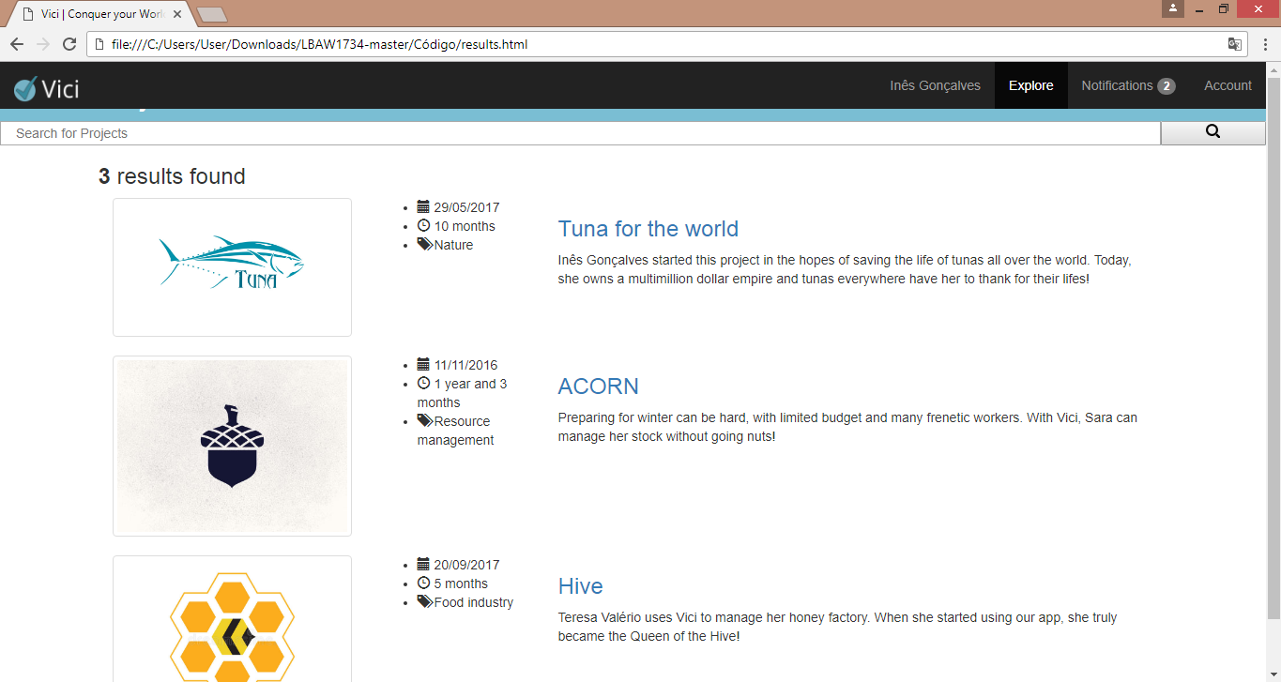(https://teresavalerio.github.io/LBAW1734/C%C3%B3digo/results.html)

Figure 13. Results page

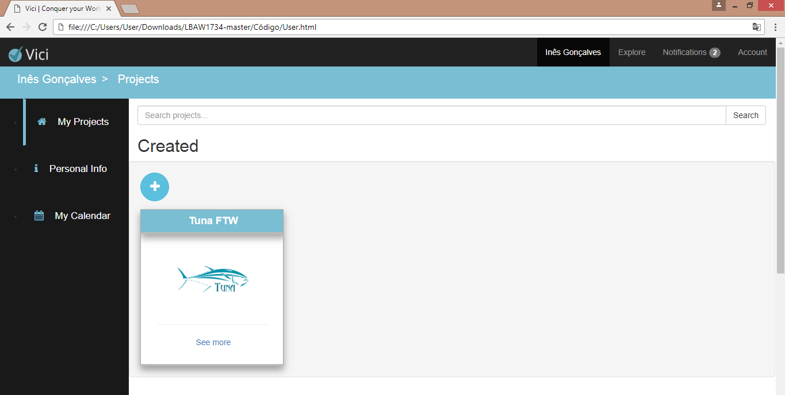**UI05 – User projects** (https://teresavalerio.github.io/LBAW1734/C%C3%B3digo/user.html)

Figure 14. User projects page

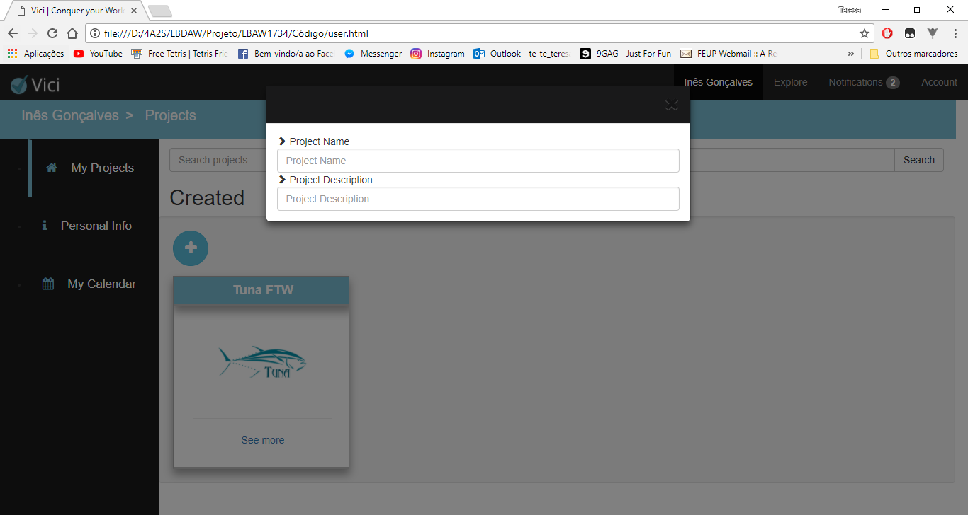**UI05 – Create project**

Figure 15. Create project pop up

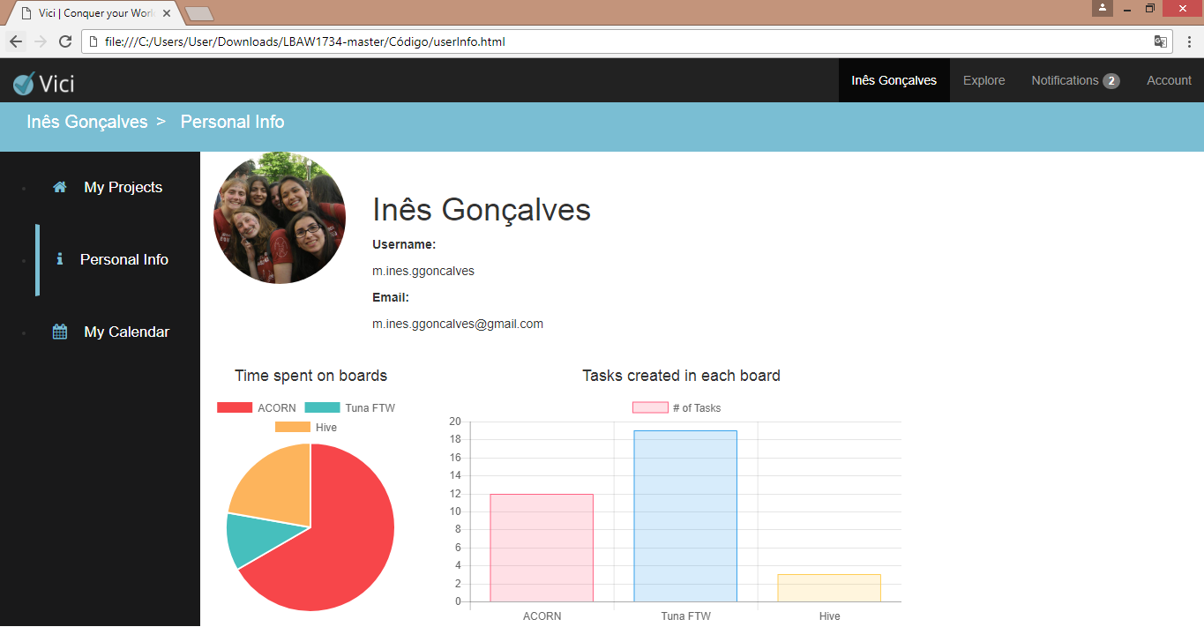**UI07 – User info** (https://teresavalerio.github.io/LBAW1734/C%C3%B3digo/userInfo.html)

Figure 16. User information page

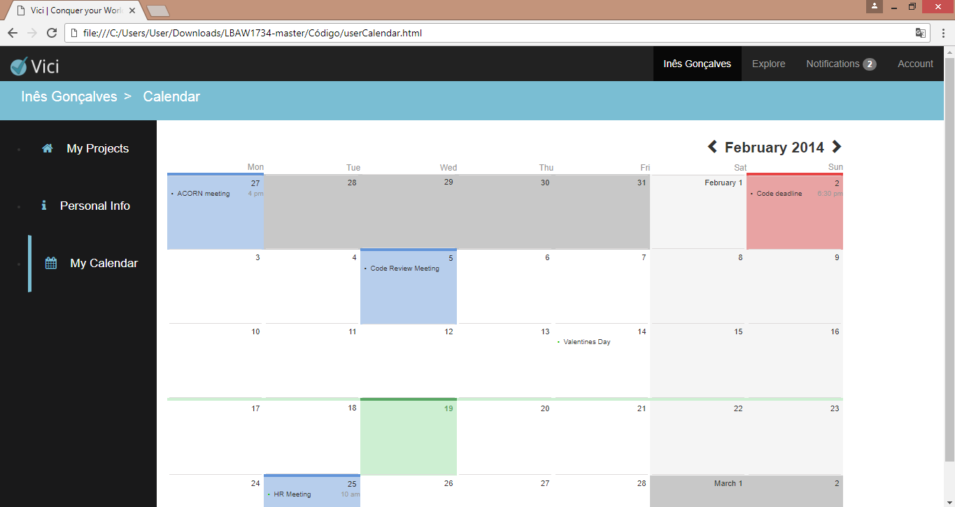**UI08 – User calendar** (https://teresavalerio.github.io/LBAW1734/C%C3%B3digo/userCalendar.html)

Figure 17. User Calendar page

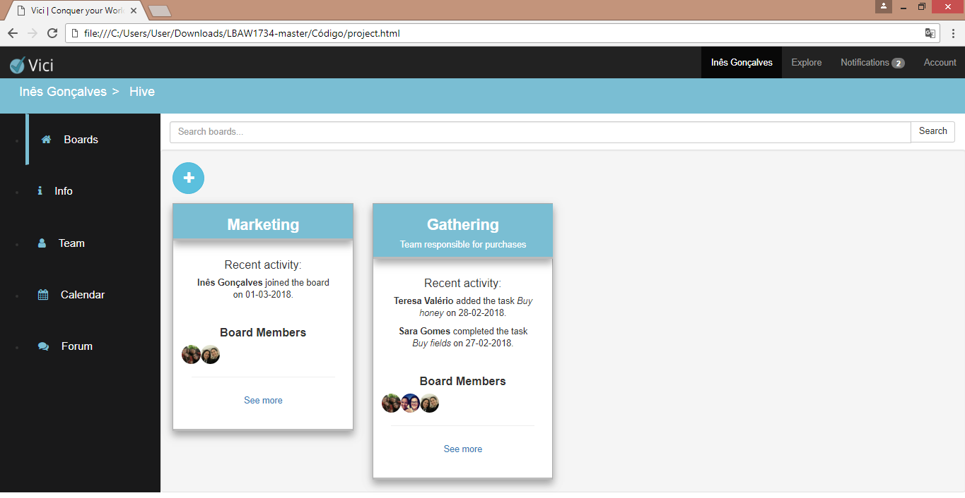**UI09 – Project boards** (https://teresavalerio.github.io/LBAW1734/C%C3%B3digo/project.html)

Figure 18. Project boards page

**UI10 – Create board**

Figure 19. Create board pop up

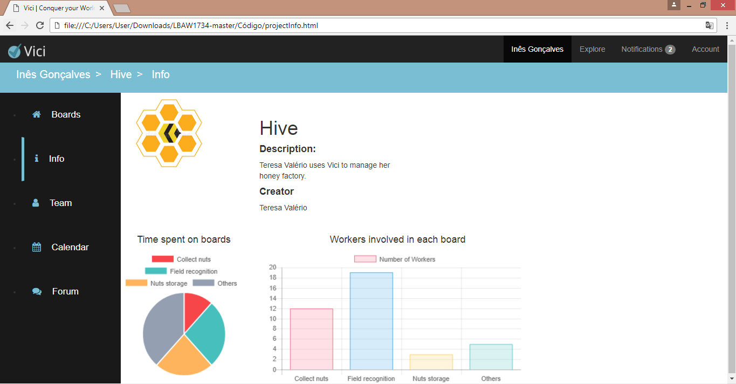**UI11 – Project info** (https://teresavalerio.github.io/LBAW1734/C%C3%B3digo/projectInfo.html)

Figure 20. Project information page

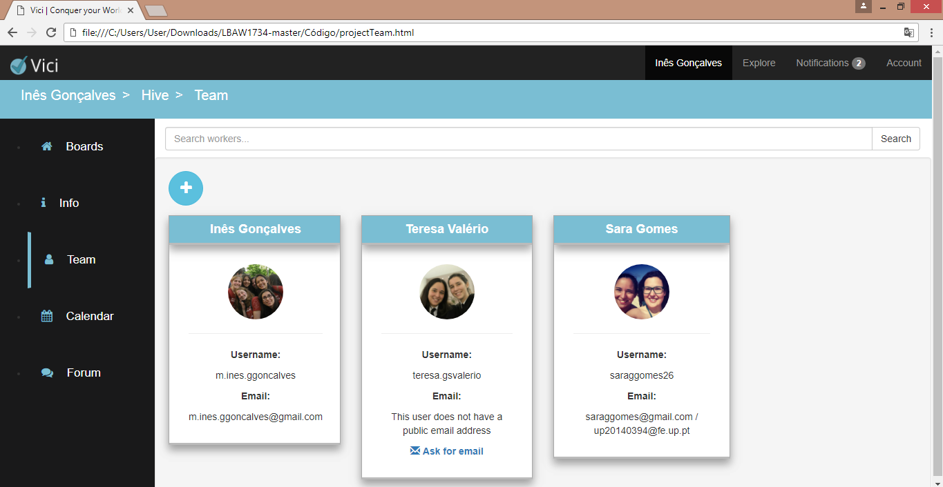**UI12 – Project team** (https://teresavalerio.github.io/LBAW1734/C%C3%B3digo/projectTeam.html)

Figure 21. Project team page

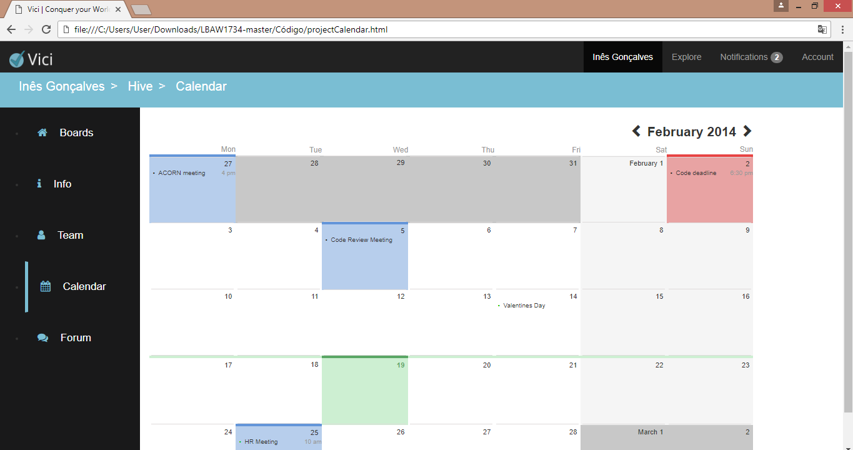**UI13 – Project calendar** (https://teresavalerio.github.io/LBAW1734/C%C3%B3digo/projectCalendar.html)

Figure 22. Project calendar page

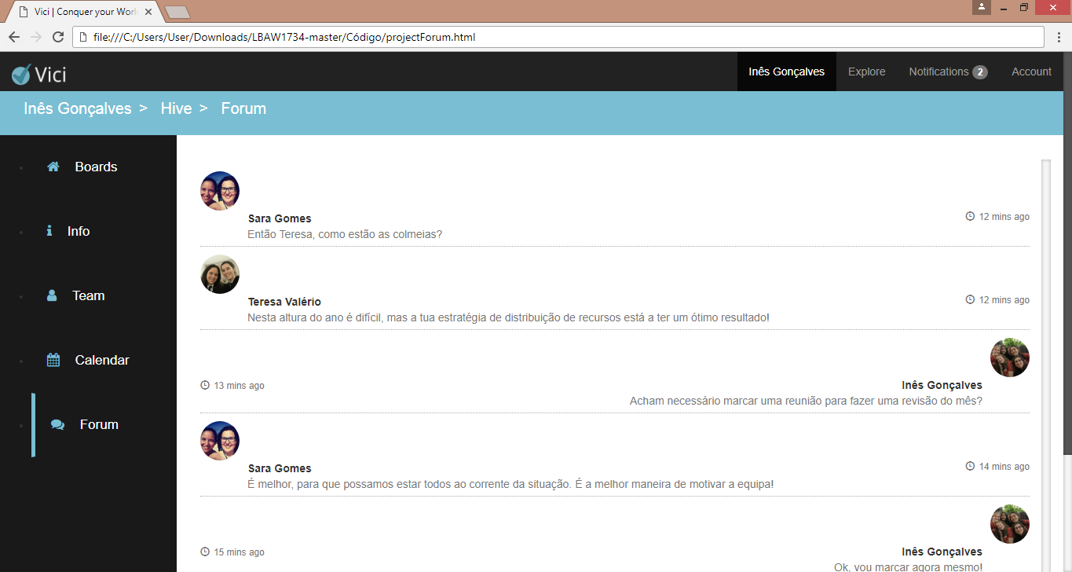**UI14 – Project forum** (https://teresavalerio.github.io/LBAW1734/C%C3%B3digo/projectForum.html)

Figure 23. Project forum page

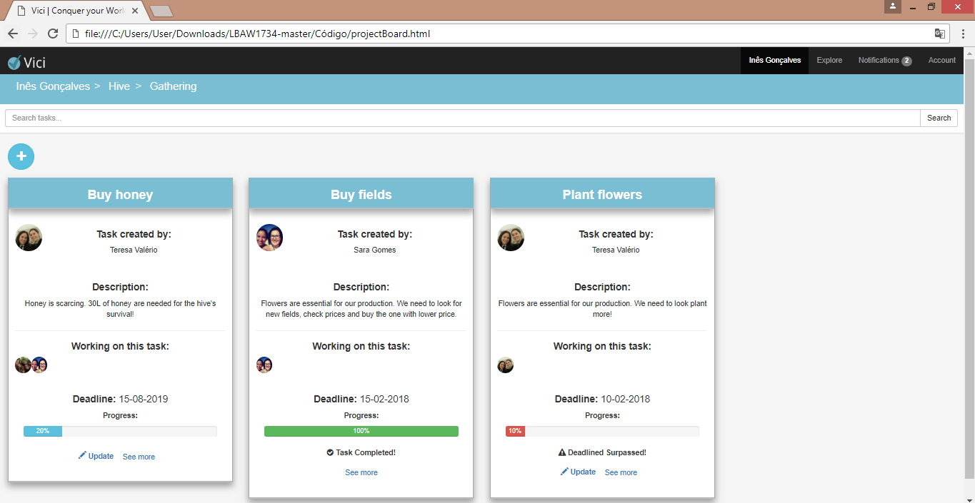**UI15 – Board tasks** (https://teresavalerio.github.io/LBAW1734/C%C3%B3digo/projectBoard.html)

Figure 24. Board tasks page

**UI16 – Create task**

Figure 25. Create tasks pop up

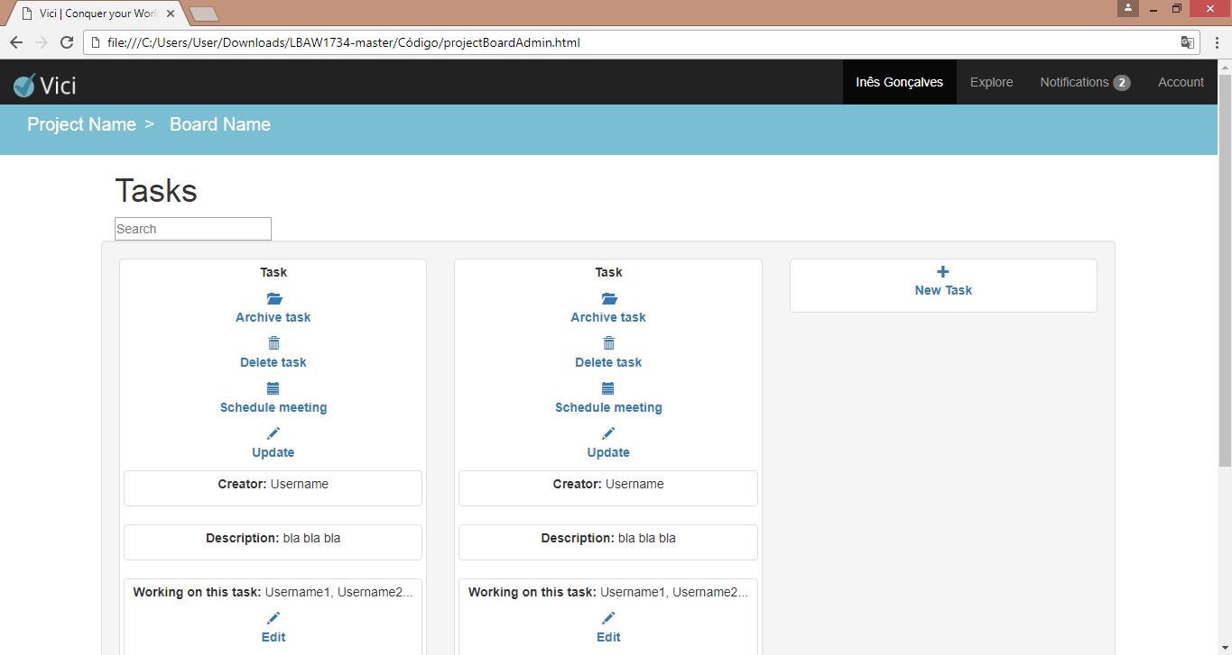**UI17 – Board tasks (coordinator version)** (https://teresavalerio.github.io/LBAW1734/C%C3%B3digo/projectBoardAdmin.html

Figure 26. Board tasks page for project coordinators

**UI18 – Task description**

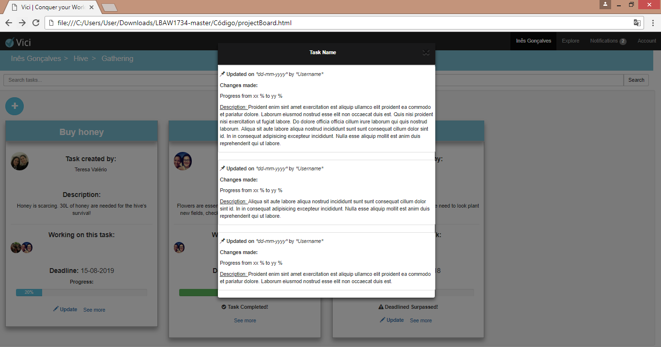

Figure 27. Task description pop up

**UI19 – Project list (administrator page)**

Figure 28. Project list page (administrator only)

**UI20 – User list (administrator page)**

Figure 29. User list page (administrator only)

**UI20 – User settings**

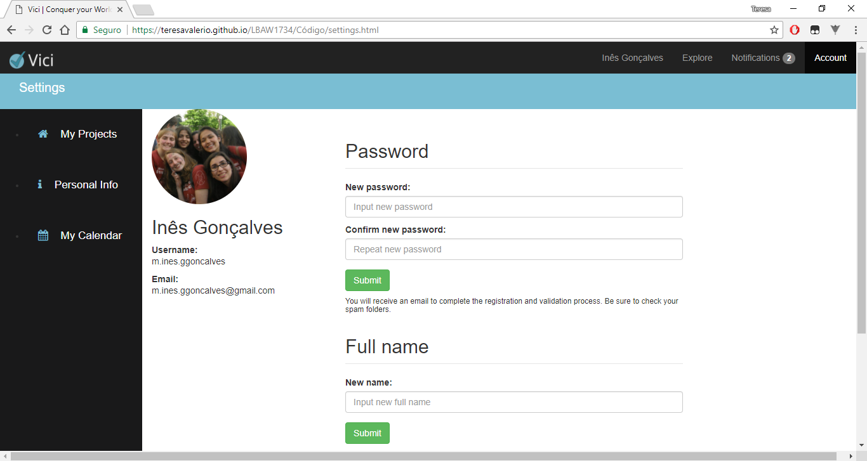(https://teresavalerio.github.io/LBAW1734/C%C3%B3digo/settings.html)

Figure 30. User settings page

Changes made to the first submission:

1. Added a more complede description of the artifact;
2. Added links for the website pages;
3. Added more complete spryboards;
4. Updated sitemap with a few changes and added UI codes for the pages;
5. Added UI19, UI20 and UI21.

GROUP1734, 11/03/2018

* Ilona Generalova, up201400035@fe.up.pt
* Maria Inês Gonçalves, up201402784@fe.up.pt
* Maria Teresa Valério, up201405655@fe.up.pt
* Sara Gomes, up201405085@fe.up.pt